**(Conditional looping logic Question)**

Q.30 What are the looping structures in JavaScript? Any one Example?

Ans :

In JavaScript, there are several looping structures that allow you to execute a block of code repeatedly. The most commonly used looping structures are:

1. for loop: A for loop repeats a block of code a specified number of times.

2.while loop: A while loop repeats a block of code as long as a specified condition is true.

3.do...while loop: A do...while loop is similar to a while loop, but it always executes the block of code at least once before checking the condition.

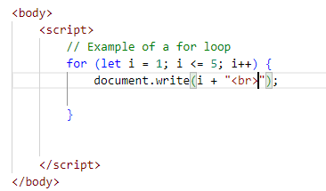

Output:

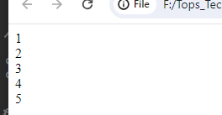

Q.31 Write a print 972 to 897 using for loop in JS?

Ans :

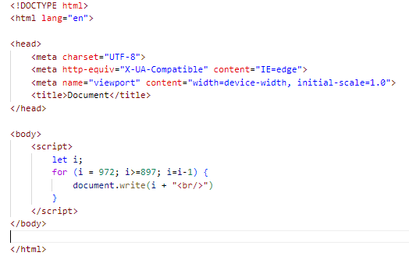

Output:



Q.32 Write to print factorial of given number?

Ans :

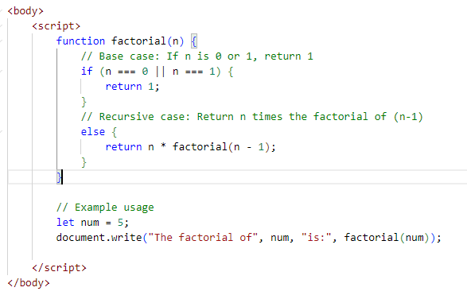

Output:

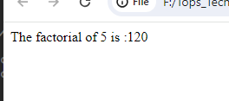

Q.33 Write to print Fibonacci series up to given numbers?

Ans:

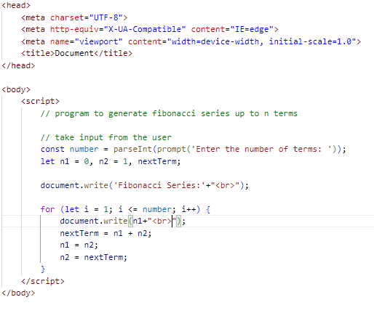

Output:

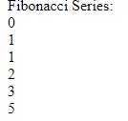

Q.34 Write to print number in reverse order e.g.: number = 64728 ---> reverse =82746 in JS?

Ans:

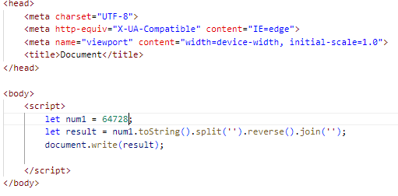

Output



Q.35 Write a program make a summation of given number (E.g., 1523 Ans: - 11) in JS?

Ans :

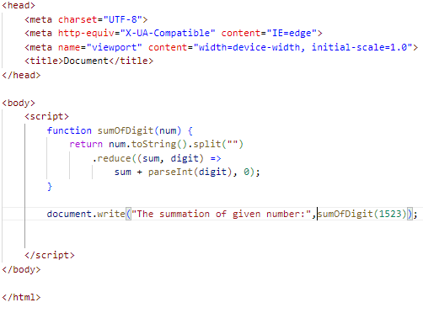

Output:



Q.36 Write a program you have to make a summation of first and last Digit. (E.g., 1234 Ans: - 5) in JS?

Ans:

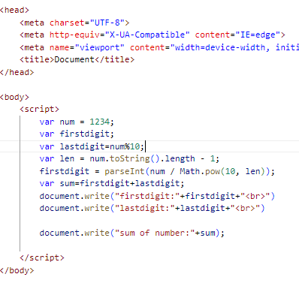

Output:

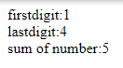

Q.37 Use console.log() and escape characters to print the following pattern in JS?

1 1 1 1 1

2 1 2 4 8

3 1 3 9 27

4 1 4 16 64

5 1 5 25 125

Ans:

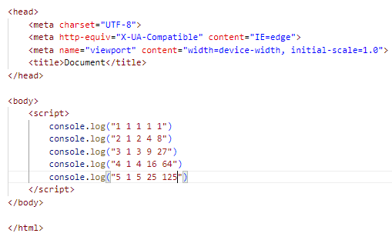

Output:

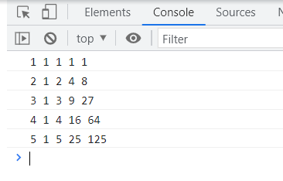

Q.38 Use pattern in console.log in JS?

1) 1

1 0

1 0 1

1 0 1 0

1 0 1 0 1

Ans :

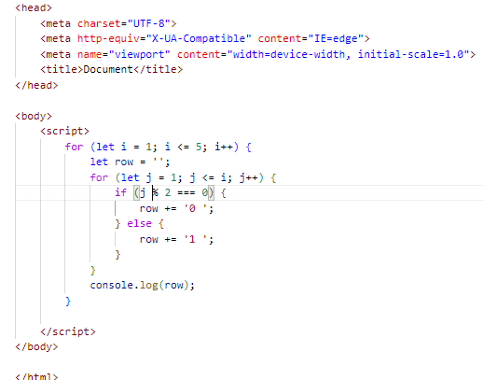

Output:

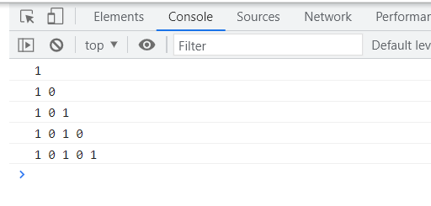

2) A

B C

D E F

G H I J

K L M N O

Ans :

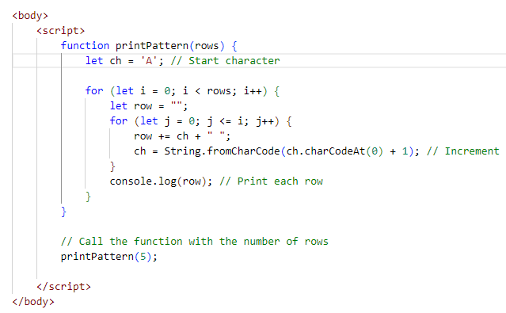

Output:

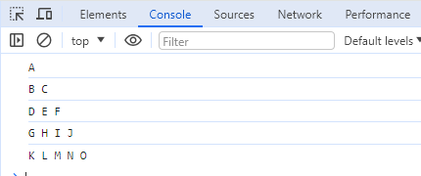

3) 1

2 3

4 5 6

7 8 9 10

11 12 13 14 15

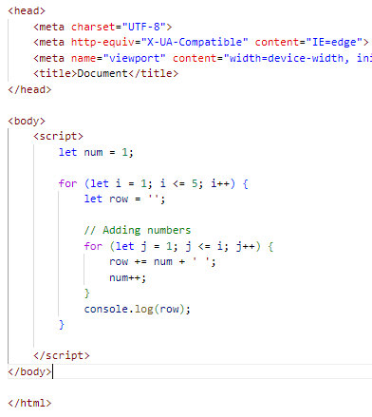

Output:

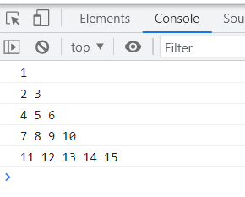

4) *

* *

* * *

* * * *

* * * * *

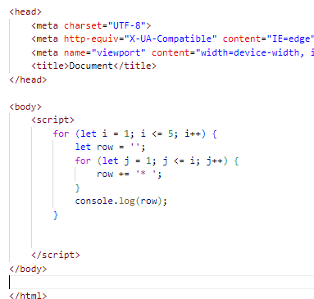

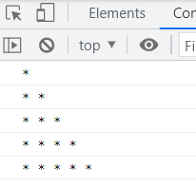

Q.39 Accept 3 numbers from user using while loop and check each numbers palindrome?

Ans :

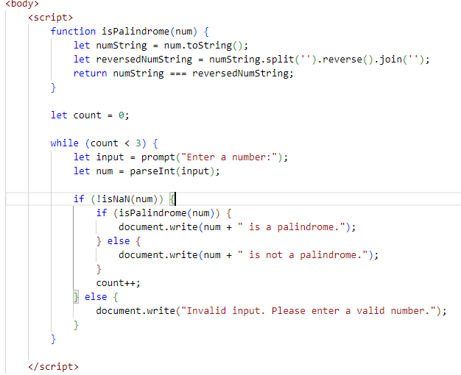

Output:

